**TASK1: CREATE A VIRTUAL MACHINE**

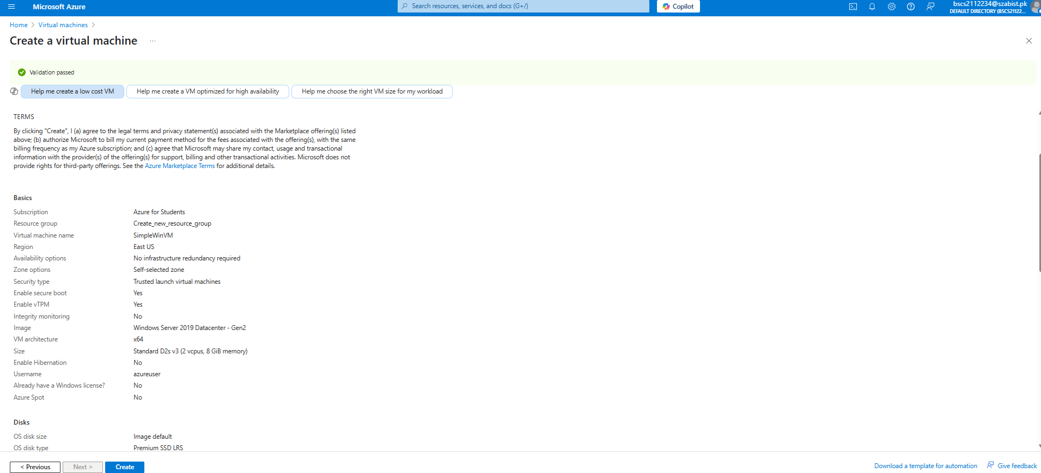

**TASK2: CREATE A NETWORK SECURITY GROUP**

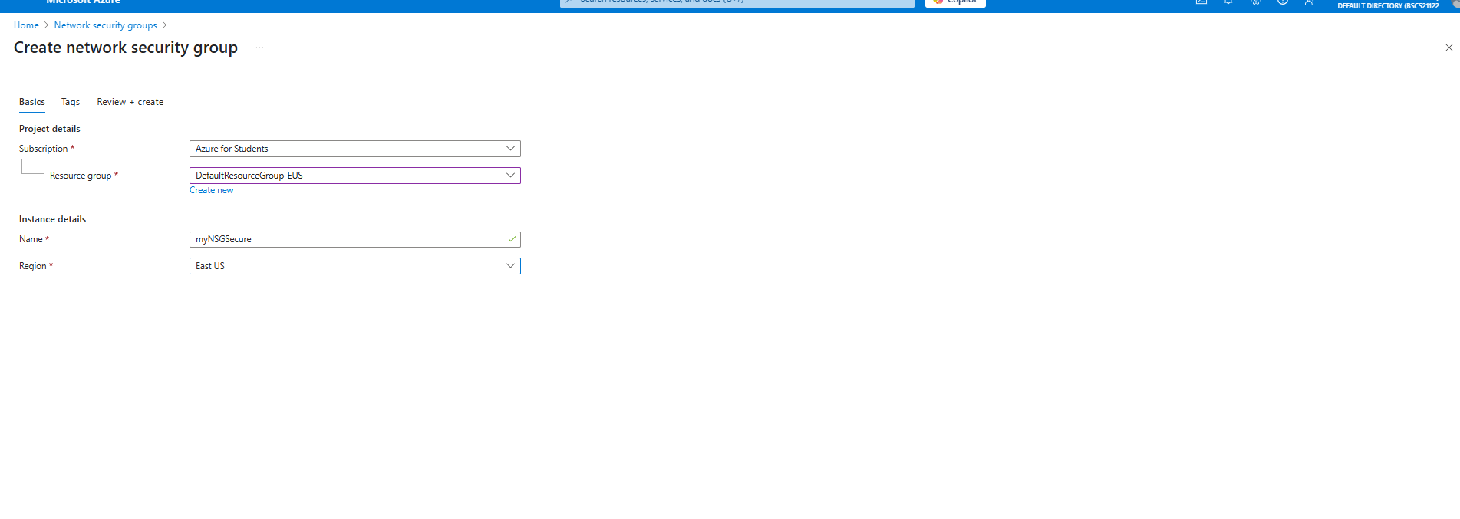

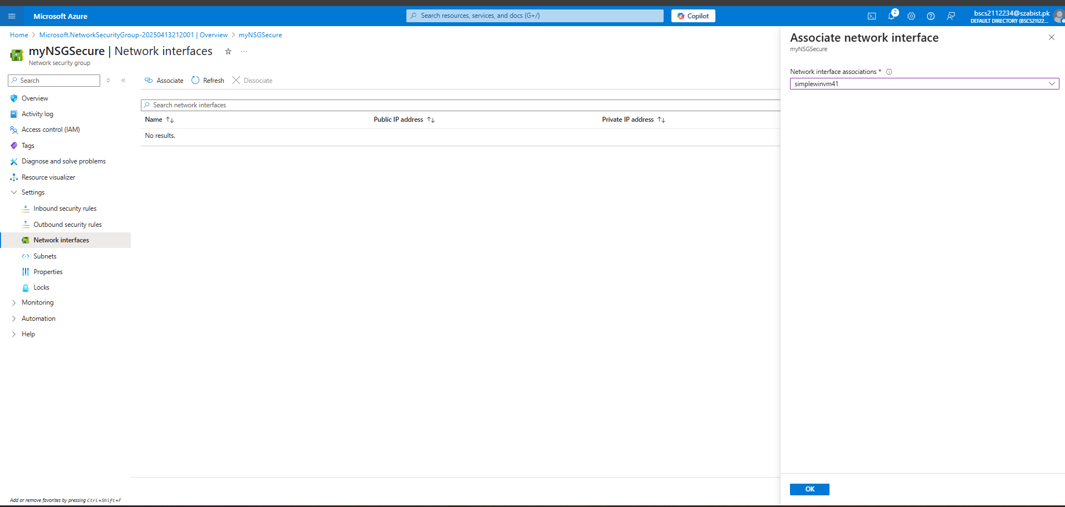

**TASK3: Configure an inbound security port rule to allow RDP**

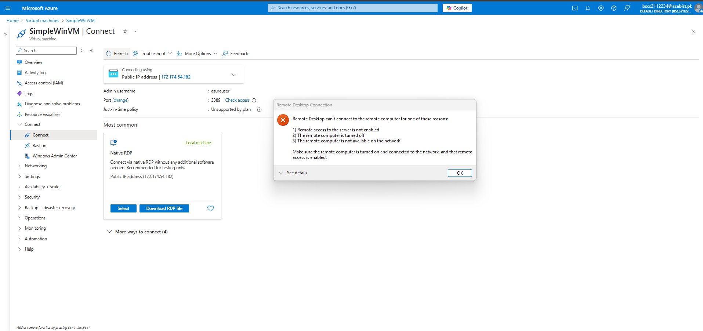

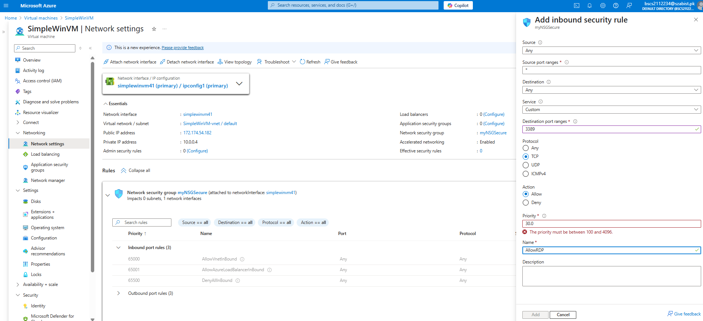

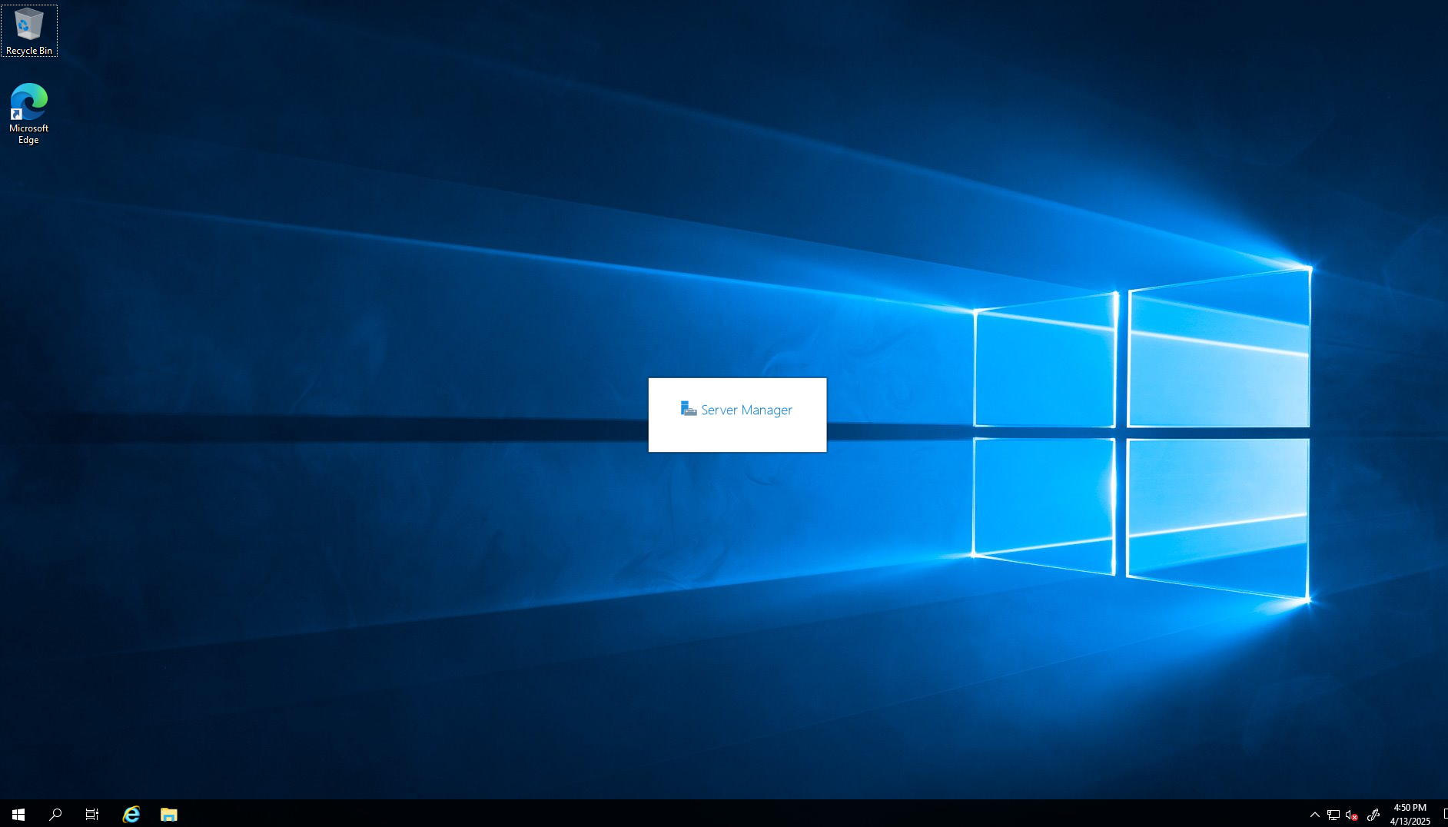

**TASK4: Configure an outbound security port rule to deny Internet access**

